Dear members and friends of the Lazarus Union!
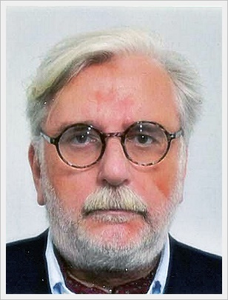
On behalf of the Lazarus Union, I would like to sincerely thank you for your dedicated participation and support in the year 2023. Your dedication and enthusiasm for our shared vision is the engine that drives the Lazarus Union and makes positive change possible.
The generous volunteer work and active participation in the Lazarus Union is invaluable. Only through this trust has it been possible to make significant progress for the future of the Lazarus Union as a modern international NGO for the 21st century.
It is inspiring to see how diverse and passionate our members are. Their ideas, suggestions and feedback are extremely important to us and help us to continuously improve our programmes and meet the needs of the people we support.
Migration, displacement, technological change, ecological and economic crises characterise human coexistence at the beginning of the 21st century.
That is why in 2023, in individual and group discussions, personal meetings, written exchanges and countless online meetings, we sought and found a strategy for the reorientation of the Lazarus Union under the motto "Lazarus Union - Strategy 2030" to position the Lazarus Union as a modern NGO of the 21st century that meets these challenges.
2030 because this is also defined in the SDGs as Agenda 2030.

THE KEY WORDS FOR THE 2024 PROGRAMME ARE:

"Autonomy instead of centralism"
By decentralising decision-making powers and resources to various units within the Lazarus Union, it is possible to make decisions locally with greater detailed knowledge. If, for example, membership issues, promotions or awards are decided locally within the agreed framework, this reduces bureaucracy and increases efficiency.

"Topics instead of people"
In future, issues will take centre stage. The Lazarus Union has committed itself to the Sustainable Development Goals (SDGs) of the United Nations. In future, each unit of the Union can define one or more of these goals as a focus for itself and raise public awareness of them with information, training, or events, either nationally or together with other units or group members.
Example:
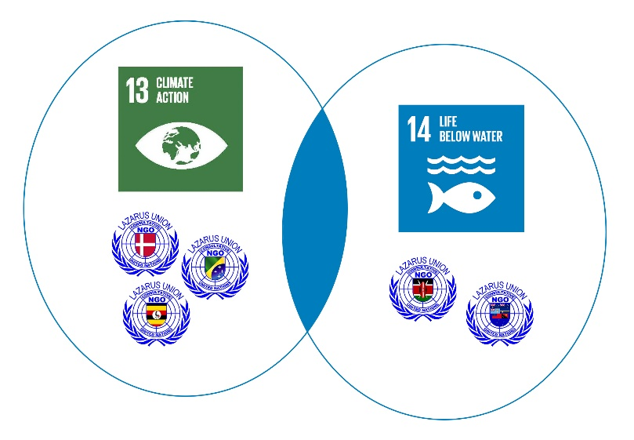
3 country units decide to focus on SDG 13 and work closely together on this topic.
2 others choose SDG 14 as a project topic. Both pools work together in nature conservation.

"Together instead of nationally"
By this we mean the suggestion that several national units, internationally or in a region (e.g. DACH - DE-AT-CH) find a way to work together more closely (informally). The problems we are confronted with today usually do not recognise national borders. This is where it makes sense to pool our expertise and develop joint strategies and programmes.

"Networking instead of going it alone“
Joint projects and partnerships can help to utilise resources more efficiently and bring about positive change. The idea of "networking" therefore emphasises the strengths that can arise from sharing knowledge, resources, and responsibilities. It is about creating synergies and achieving common goals instead of acting in isolation.
As usual, there will also be plenty of material on the UN Days of Remembrance and our own projects and awareness-raising measures, for use on websites, in social media, at talks, events or in school lessons.
I would like to encourage everyone to continue to take an active part in the Lazarus Union or, if you are not yet familiar with the Lazarus Union, to share your opinions and contribute new ideas.
So, if you have an idea or a cause you would like to champion, I encourage you to invite others to join us. When we all pool our skills, ideas, and resources, we can help solve problems, find innovative solutions, and make a positive impact in our communities.
Thank you again for your trust and co-operation, for all members to date, and perhaps for you in the future?
We look forward to continuing our journey together for a better future.
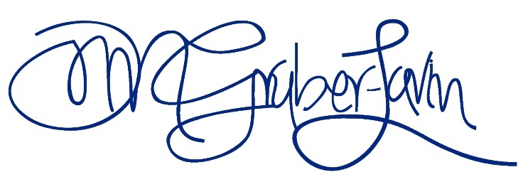
Merry Christmas and a prosperous New Year!
COL HON Oliver M. Gruber-Lavin y Ochoa FRSA
Chief Representative Lazarus Union International

See our big pilot project in Uganda =>

PROJECT PRESENTATION: JOINT VENTURE IN UGANDA
The Lazarus Union is one of 5 partners in a joint venture in Uganda (a priority country for Austrian development co-operation since 1992).
The 100% state-owned company "National Enterprise Corporation" (NEC) will establish a company called "Beef & Beans Ltd." as part of a joint venture. This NEC JV, specifically a meat processing company (canning production) with an associated slaughterhouse for cattle, does not require any purely economic support as the purchase of production capacity has already been secured in advance.
The aim of the project is to reduce Uganda's dependence on imports, especially the annual meat imports (e.g. tins of corned beef from South America), by substituting high-quality products from local production, reducing CO2-polluting supply chains, and thus significantly reducing the environmental impact, while at the same time industrialising its own food production in a sustainable and responsible manner and strengthening the national currency.
The national importance of such projects stems from the fact that agriculture accounts for around 22.5 per cent of Uganda's economic output, contributes over a third of foreign exchange earnings and creates by far the most jobs (2022).
The entire project is financed without subsidies, exclusively from within the country.

JOINT VENTURE PARTNER
APPLICANT | IRONBRIDGE is a general contractor that offers complete, ecological, efficient, and cost-effective solutions for projects in the field of sustainable industrialisation. The transfer of technology is closely linked to the transfer of knowledge
JV PARTNER | The National Enterprise Corporation (NEC) was established by an Act of Parliament in 1989 to produce and provide goods and services to the Defence Forces (UPDF), UPDF veterans and the public. Its commercial ventures are carried out through its subsidiaries and joint ventures.
LOCAL PARTNER | "Stewart-Marshall-Industries" assists in the realisation of development projects. With innovative thinking, many years of experience and broad expertise in the field of mechanical engineering, plant engineering and automation technology, Stewart-Marshall-Industries develops new technical systems, creates innovative designs and finds the perfect product solution.
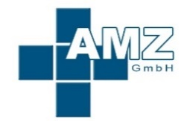  LABORATORY OPERATOR | AMZ GmbH, which also acts as the laboratory operator, has the task of ensuring that the working conditions for employees are harmless to health and comply with legal requirements. The centre ensures that all legal requirements in the field of occupational and veterinary medicine are complied with.
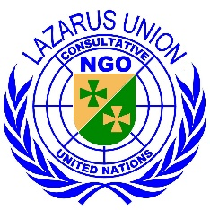  GOOD GOVERNANCE | The Lazarus Union, an internationally active NGO & NPO with general advisor status at the Economic and Social Council of the United Nations (ECOSOC), is involved in the planning and implementation of the joint venture and monitors the implementation of the Global Compact's core values in the areas of human rights, labour standards, the environment and anti-corruption as well as compatibility with the United Nations' sustainability goals.

The Lazarus Union will:
- prevent the project from causing adverse impacts on human rights and address such impacts if they occur.
- endeavour to prevent adverse human rights impacts in connection with the project partners' relations with third parties that are causally linked to the activities or services of the project partners.
- The Lazarus Union will reflect its commitment to human rights in relevant policies and procedures, risk assessment processes, due diligence, and training programmes as part of its overall approach to environmental, social and governance (ESG) risks.
Lazarus Union takes a risk-based approach to determine when enhanced due diligence is required to understand, assess, and address potential human rights violations associated with all project partner activities and relationships.

FACILITY ON SITE (STATUS 12/2023)
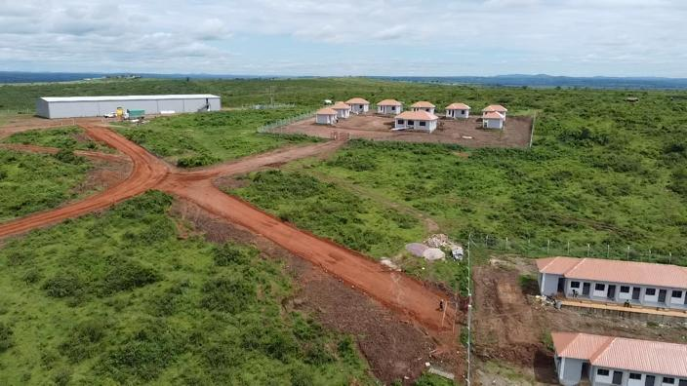
In the background on the left is the processing plant, in the centre (model) houses for accommodation, in the foreground workshops in which handicraft items are subsequently produced as part of the "Ankole Heritage Project". (, there were considerable delays due to Covid19 on the one hand and supply chain disruptions on the other, full operation is expected for 1-2Q 24)

 | 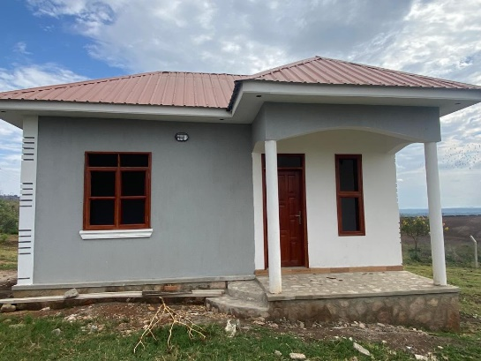 | 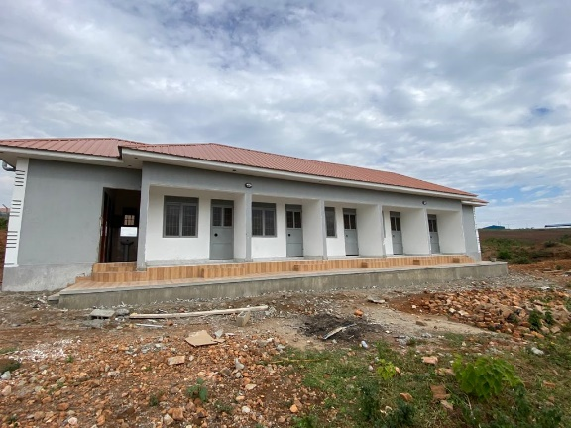
(Model) house |  | workshop
During reforestation, 1 fruit tree is planted for every order in the web shop.

